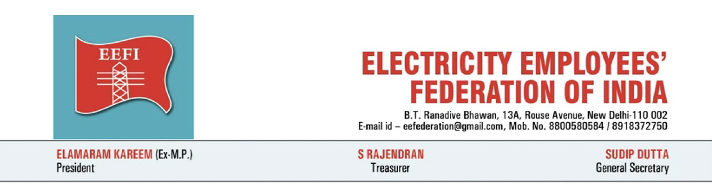
Date: 23 October 2026
Press Note
Historic victory of Haryana power employees and engineers. Government agrees to issue Section 108 direction; strike called off after 48 hours of resolute struggle

The Electricity Employees’ Federation of India (EEFI) salutes the power employees and engineers of Haryana who, under the banner of the Haryana Electricity Employees and Engineers Joint Struggle Front, have successfully concluded a historic two-day statewide strike. The strike, which began at 10 pm on 21 October and continued with full vigour through 22 and 23 October, has forced the Government of Haryana to agree to issue a policy direction under Section 108 of the Electricity Act, 2003 against the parallel distribution licence granted to Eleven Power Private Limited for Gurugram and Nuh. The Hon’ble Chief Minister has announced this decision publicly and made it clear that parallel licence will not be allowed in Haryana. In the light of these assurances, the Joint Struggle Front has decided to call off the strike.
Around 40,000 to 55,000 employees and engineers joined the strike across the State. Participation was near-total in both Dakshin and Uttar Haryana Bijli Vitran Nigams and in the transmission utility. The strike brought electricity supply to a standstill in large parts of Haryana. Prolonged outages disrupted homes, water supply, offices and industrial units. Residents faced blackouts lasting many hours, yet they stood with the cause. Farmers’ organisations, trade unions and ordinary consumers extended support even while bearing the inconvenience. Employees ensured that essential supplies to hospitals were protected. The strength of the strike and the public’s solidarity made the agitation a true people’s movement.
The decision of the Government to issue a Section 108 policy direction and the public announcement by the Chief Minister that parallel licence will not be allowed in Haryana mark a significant victory of the struggle. EEFI welcomes this stand and calls upon the Government to issue the written direction without delay, place it on record in the appeal before the Appellate Tribunal for Electricity, and ensure that no step is taken to operationalise the licence granted to Eleven Power.
The 48-hour strike has shown that electricity employees and engineers, supported by the people, will not allow public distribution utilities to be weakened for private profit. The fight against the parallel licence is not over. Vigilance must continue until the policy direction is issued, the appeal is pursued, and the licence is not allowed to take effect. EEFI congratulates every employee, engineer, farmer, worker and citizen who made this struggle a grand success.
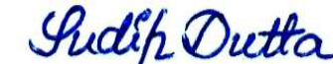
Sudip Dutta
General Secretary

