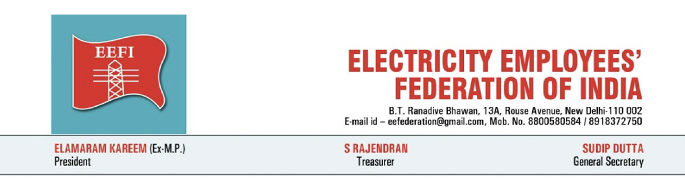
Date: 23 October 2026
Press Note
Strike continues; EEFI demands immediate Section 108 direction and public announcement by Haryana Chief Minister
The Electricity Employees’ Federation of India (EEFI) salutes the power employees and engineers of Haryana who are continuing their historic three-day statewide strike under the banner of the Haryana Electricity Employees and Engineers Joint Struggle Front against the HERC order of 19 October 2026 granting a parallel distribution licence to Eleven Power Private Limited for Gurugram and Nuh.
The strike has demonstrated the determination of employees, engineers, consumers and farmers to defend public electricity distribution. EEFI reiterates its full support to the ongoing struggle and its demand for immediate cancellation of the licence.
The Government of Haryana has held meetings with the unions and has indicated readiness to issue a policy direction under Section 108 of the Electricity Act, 2003. This is a necessary step. Filing an appeal before the Appellate Tribunal for Electricity is not a substitute for a clear policy stand. Section 108 empowers the State Government to issue directions in matters of policy involving public interest, by which the Commission shall be guided. EEFI has already submitted a draft policy direction to the Government recording that parallel licensing is not the policy of the State and that distribution shall continue through the existing public utilities.
In Karnataka, a clear public stand by the Chief Minister against parallel licensing compelled Tata Power to withdraw its applications. EEFI demands that the Hon’ble Chief Minister of Haryana make a similar public announcement that Eleven Power Private Limited will not be permitted to carry on the business of parallel distribution of electricity in the State. The Government must act without delay: issue the Section 108 direction, place it on record in the appeal, seek a stay, and withhold all right-of-way and clearances for any parallel network.
EEFI warns against any attempt to suppress the strike through force, ESMA, FIRs or victimisation. The fight in Haryana is a fight to defend public electricity distribution against corporate profiteering. EEFI calls upon its constituent organisations across the country to intensify solidarity actions.
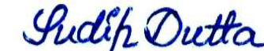
Sudip Dutta
General Secretary

