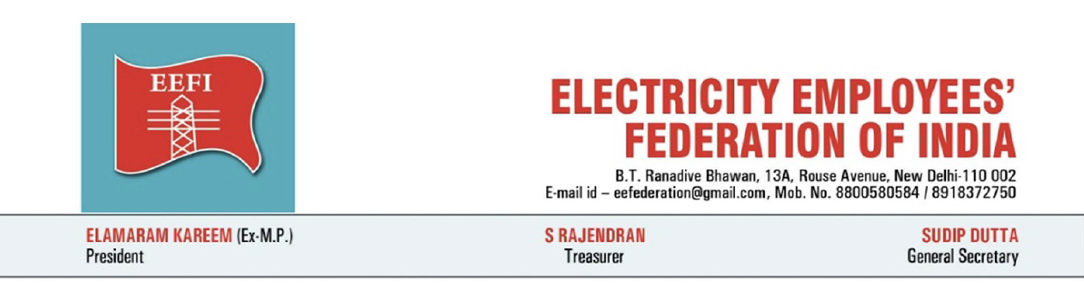

To
The Hon’ble Chief Minister
Government of Haryana
Chandigarh

Hon’ble Sir,
Subject: Draft policy direction under Section 108 of the Electricity Act, 2003 against parallel distribution licensing — HERC Order dated 19.10.2026 in Petition No. 30 of 2026
Ref:
- HERC Order dated 19.10.2026 in Petition No. 30 of 2026.
- Caveat filed by Eleven Power Private Limited before the Appellate Tribunal for Electricity on 21.10.2026.

We have noted that the Government is in dialogue with electricity employees and engineers and has indicated readiness to issue a policy direction under Section 108 of the Electricity Act, 2003, while also pursuing the appeal before the Appellate Tribunal for Electricity against the order granting a 25-year parallel distribution licence to Eleven Power Private Limited for Gurugram and Nuh.
Eleven Power has already filed a Caveat before APTEL on 21.10.2026 naming the State utilities, EEFI and other objectors as expected appellants, and praying that no interim order be passed without notice to it. This makes it all the more necessary that the Government file the appeal promptly, seek a stay, and place a clear Section 108 policy direction on record.
A clear policy direction, accompanied by a public announcement by the Hon’ble Chief Minister, will strengthen the Government’s position and give a clear signal that parallel licensing is not the policy of the State.
In Karnataka, when Tata Power applied for parallel distribution licences, the Chief Minister and the Cabinet publicly stated that the Government would not allow private participation in distribution and would not give consent. The state utilities filed objections. Tata Power withdrew the applications. In Maharashtra, applications by private companies for parallel licences faced strong opposition from the state utility and unions; the Government assured that it did not support privatisation and would oppose parallel licensing before the Commission.
We request that the Government of Haryana:
- Issue the enclosed draft policy direction under Section 108 of the Electricity Act, 2003 without delay.
- Make a clear public announcement by the Hon’ble Chief Minister that parallel distribution licensing is not the policy of the State of Haryana, and that Eleven Power Private Limited will not be permitted to carry on the business of parallel distribution of electricity in the State.
- Pursue the appeal before APTEL with full seriousness, seek a stay on implementation of the order, and place the Section 108 direction on record in the appeal.
- Direct that no right-of-way, land, clearances or other facilitation be given for construction of a parallel network or for consumer migration pending the appeal and the policy direction.
Yours faithfully,

Sudip Dutta
General Secretary

Encl: A draft of the proposed Section 108 direction for your perusal
Annexure-Draft Section 108 Policy Direction-

Government of Haryana
Department of Power

No. __________
Dated: __________

Direction under Section 108 of the Electricity Act, 2003
Whereas the Haryana Electricity Regulatory Commission, by order dated 19.10.2026 in Petition No. 30 of 2026, has granted a parallel distribution licence to Eleven Power Private Limited for the revenue districts of Gurugram and Nuh;
And whereas the State Government has consistently opposed the grant of any parallel distribution licence in the State, and has decided to challenge the said order before the Appellate Tribunal for Electricity;
And whereas Gurugram and Nuh together constitute a substantial share of the sales and revenue of the incumbent distribution licensee, Dakshin Haryana Bijli Vitran Nigam Limited, and the grant of a parallel licence carries the risk of selective migration of high-paying consumers, stranding of power-purchase and network costs, erosion of cross-subsidy for agricultural and domestic consumers, and weakening of the financial position of the public distribution utilities;
And whereas the applicant is a recently incorporated company without an operating distribution system of its own, and the State has no notified framework governing consumer migration, settlement of arrears including fuel surcharge, or recovery of stranded costs on full switch-over;
And whereas electricity distribution is a public utility service essential to the life and livelihood of the people of the State, and the public interest requires that distribution continue through the existing public utilities which are owned and controlled by the State;
And whereas Section 108 of the Electricity Act, 2003 empowers the State Government to issue directions in matters of policy involving public interest, by which the State Commission shall be guided in the discharge of its functions, and the decision whether any such direction relates to a matter of policy involving public interest rests with the State Government;
Now, therefore, in exercise of the powers conferred by Section 108 of the Electricity Act, 2003, the Government of Haryana hereby issues the following direction in the matter of policy involving public interest:
- It is the policy of the State of Haryana that parallel distribution licensing is not in the public interest, and that electricity distribution in the State shall continue through the existing public distribution utilities.
- The Haryana Electricity Regulatory Commission shall be guided by this policy in all matters relating to the implementation, modification, extension or further grant of any parallel distribution licence, including in relation to the licence granted to Eleven Power Private Limited for Gurugram and Nuh.
- No step which facilitates the construction of a parallel distribution network, the grant of right-of-way or clearances for such network, or the migration of consumers from the incumbent licensee shall be taken in a manner inconsistent with this policy, pending the outcome of the appeal before the Appellate Tribunal for Electricity and any further order of the Commission consistent with this direction.
- The Commission shall, in any proceeding arising out of or connected with the said licence, have due regard to the impact on residual consumers, cross-subsidy, stranded power-purchase and network costs, universal service obligation, and the financial sustainability of the public distribution utilities.
- This direction shall be placed on record before the Appellate Tribunal for Electricity in the appeal preferred by the State, and shall be communicated to the Haryana Electricity Regulatory Commission, the State transmission and distribution utilities, and all concerned departments.
By order of the Governor of Haryana
Secretary to Government
Department of Power

